SET PASSWORD
# Source: AI Source: Provided by: [Data Path: Persons Table -> ID Column: 1, Name_En Column: Motasem Essam] -> From: [ChatGPT] on [6/11/2026]
The SET PASSWORD statement is used to change the password of a MySQL user.

✅ 1. Basic Syntax
# Source: AI Source: Provided by: [Data Path: Persons Table -> ID Column: 1, Name_En Column: Motasem Essam] -> From: [ChatGPT] on [6/11/2026]
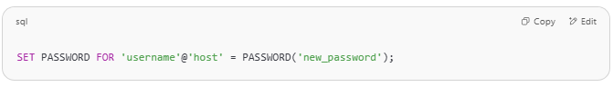
SET PASSWORD FOR 'username'@'host' = PASSWORD('new_password');

🔧 Example
# Source: AI Source: Provided by: [Data Path: Persons Table -> ID Column: 1, Name_En Column: Motasem Essam] -> From: [ChatGPT] on [6/11/2026]
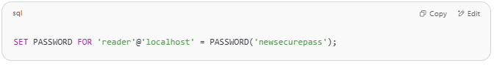
SET PASSWORD FOR 'reader'@'localhost' = PASSWORD('newsecurepass');

This sets the password for the user reader to 'newsecurepass'.
Note: The PASSWORD() function is deprecated in MySQL 5.7+ and removed in MySQL 8.0.
For MySQL 8.0+, use:
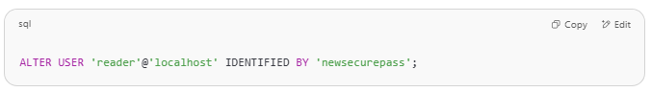
ALTER USER 'reader'@'localhost' IDENTIFIED BY 'newsecurepass';

✅ 2. remove a password
To remove a password from a MySQL user (i.e., allow them to log in without a password), you can do this:

✅ For MySQL 5.7 and later (using ALTER USER):
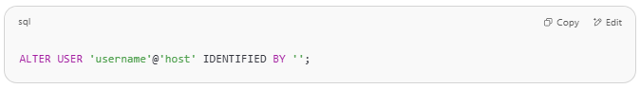
ALTER USER 'username'@'host' IDENTIFIED BY '';

🔹 Example:
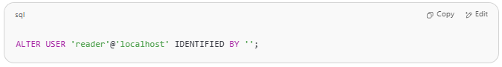
ALTER USER 'reader'@'localhost' IDENTIFIED BY '';

This sets the password to an empty string, effectively removing it.

⚠️ Important Notes:
- Not recommended for production! Removing passwords creates a serious security risk.
- Your MySQL server might be configured to disallow empty passwords (--skip-grant-tables must be off, and validate_password policy might block weak/empty passwords).
- If you get a policy error, you can temporarily lower the password policy (not recommended on production):
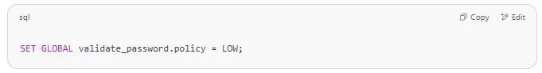
SET GLOBAL validate_password.policy = LOW;

✅ Alternative (MySQL 8+): Use auth_socket plugin (for local auth)
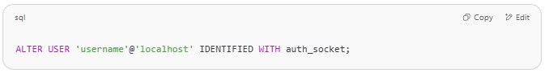
ALTER USER 'username'@'localhost' IDENTIFIED WITH auth_socket;

This lets the user authenticate via system login (Linux socket), without a password.

✅ 3. Change Password for Current User
# Source: AI Source: Provided by: [Data Path: Persons Table -> ID Column: 1, Name_En Column: Motasem Essam] -> From: [ChatGPT] on [6/11/2026]
If you're logged in as the user whose password you want to change, you can simply do:
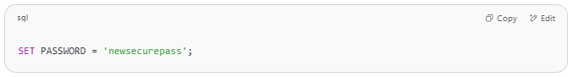
SET PASSWORD = 'newsecurepass';

In MySQL 8.0+, use:
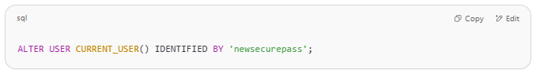
ALTER USER CURRENT_USER() IDENTIFIED BY 'newsecurepass';

✅ 4. remove a password for Current User
To remove the password of the current user in MySQL, follow the instructions below:

✅ Remove Password for the Current User

🔹 For MySQL 5.7 and above:
You can run:
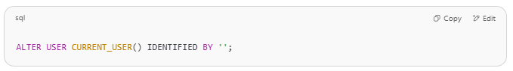
ALTER USER CURRENT_USER() IDENTIFIED BY '';

This sets your password to an empty string.

🔹 For Older Versions:
If ALTER USER is not supported, try:
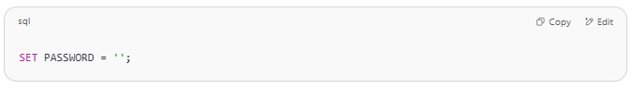
SET PASSWORD = '';

This also clears the current user’s password.

⚠️ Important Notes:
- You must have sufficient privileges (likely not possible on hosted environments).
- If your server uses the validate_password plugin, it might block empty passwords.

🔍 Optional: Check Current User
Before running the command, you can check who you’re logged in as:
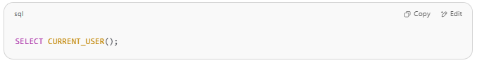
SELECT CURRENT_USER();

Would you like help verifying if password removal worked or if your MySQL version allows it?

⚠️ Permissions Required
# Source: AI Source: Provided by: [Data Path: Persons Table -> ID Column: 1, Name_En Column: Motasem Essam] -> From: [ChatGPT] on [6/11/2026]
- You must have the UPDATE privilege on the mysql database, or be the account owner.
- Only the root user (or a user with ALTER USER privileges) can change other users’ passwords.

🧪 Example Full Workflow
# Source: AI Source: Provided by: [Data Path: Persons Table -> ID Column: 1, Name_En Column: Motasem Essam] -> From: [ChatGPT] on [6/11/2026]
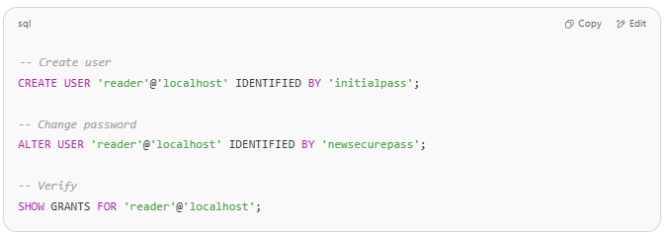
-- Create user
CREATE USER 'reader'@'localhost' IDENTIFIED BY 'initialpass';

-- Change password
ALTER USER 'reader'@'localhost' IDENTIFIED BY 'newsecurepass';

-- Verify
SHOW GRANTS FOR 'reader'@'localhost';

Would you like a test script you can run in phpMyAdmin to create a user, change their password, and check it?

Example 1

prepared commands
# Source: ScreenShot Source: Provided by: [Persons Table -> ID Column: 1, Name_En Column: Motasem Essam] -> Tool: [Automation Table -> ID Column: 16, Name_En Column: Screen Capture] -> From [Operating System: Wampserver64 -> phpmyadmin] on [6/11/2026]
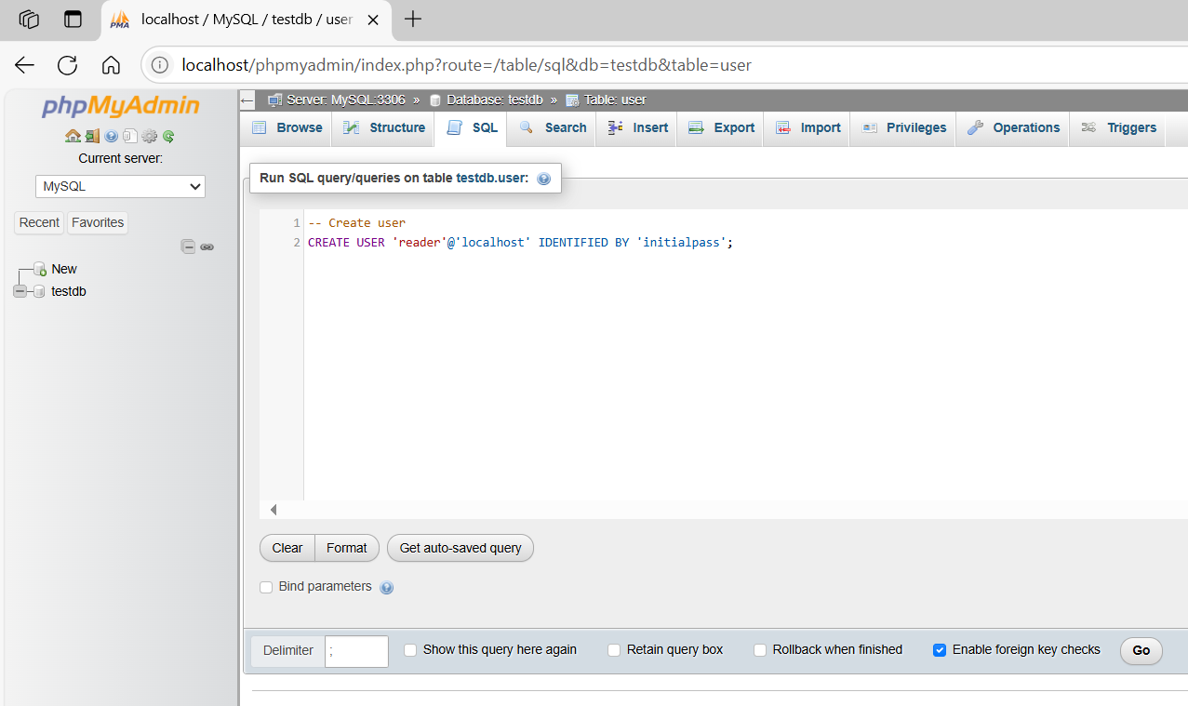
-- Create user
CREATE USER 'reader'@'localhost' IDENTIFIED BY 'initialpass';
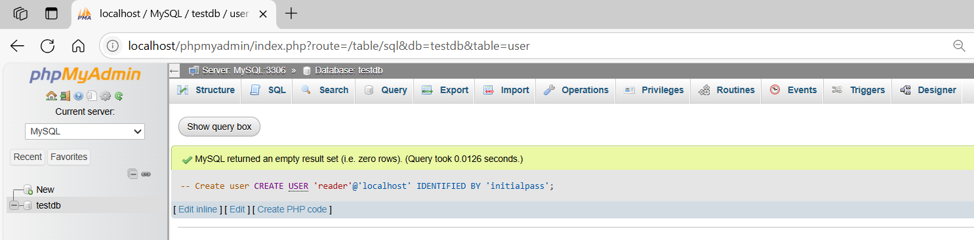

basic command
# Source: ScreenShot Source: Provided by: [Persons Table -> ID Column: 1, Name_En Column: Motasem Essam] -> Tool: [Automation Table -> ID Column: 16, Name_En Column: Screen Capture] -> From [Operating System: Wampserver64 -> phpmyadmin] on [6/11/2026]
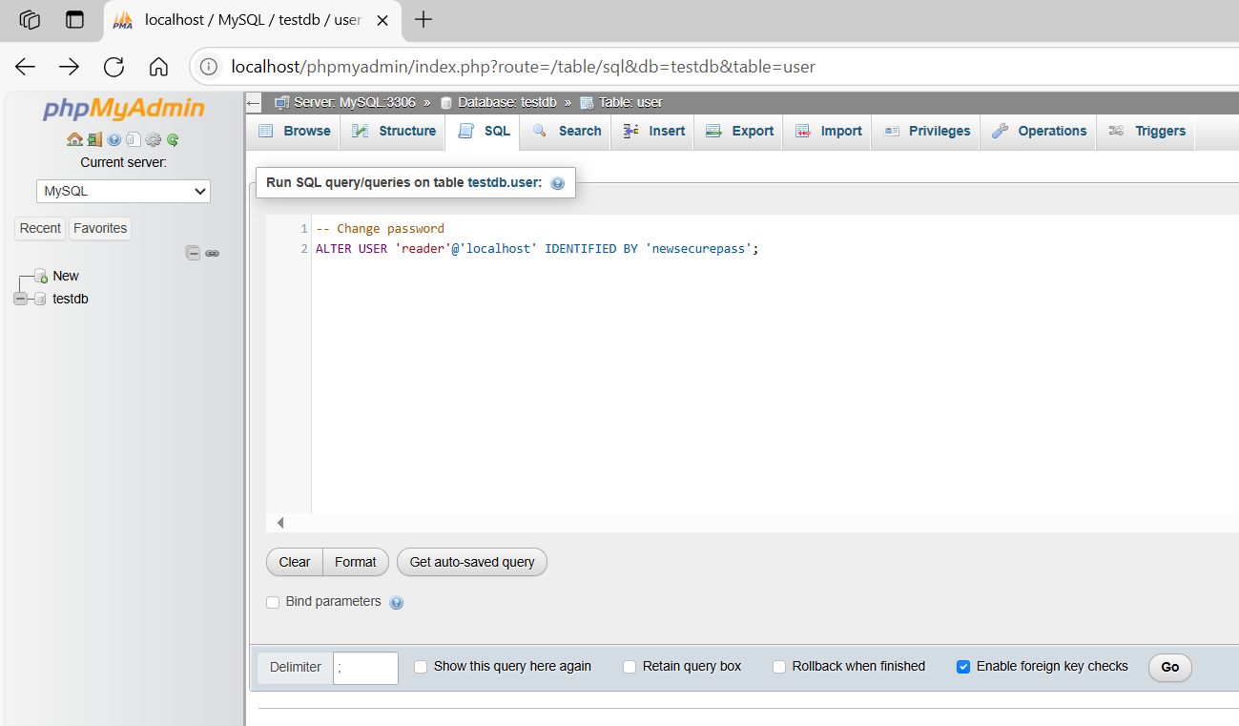
-- Change password
ALTER USER 'reader'@'localhost' IDENTIFIED BY 'newsecurepass';
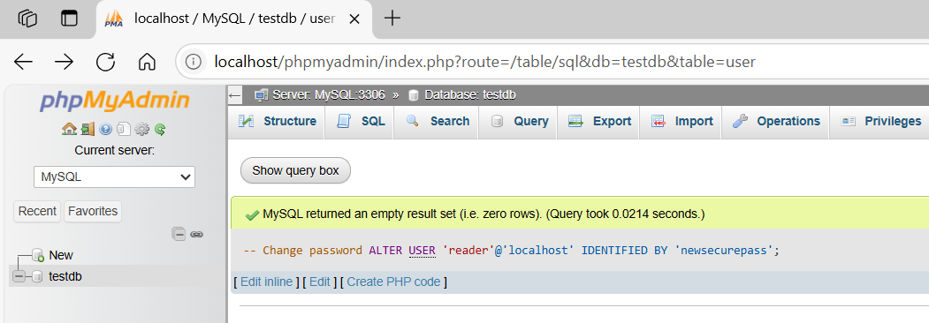
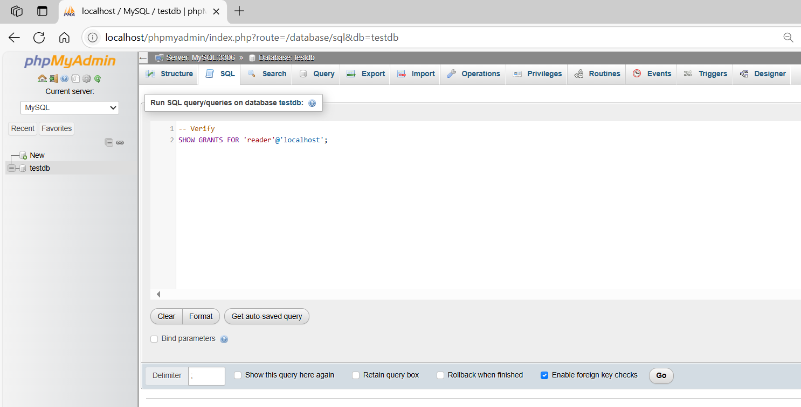
-- Verify
SHOW GRANTS FOR 'reader'@'localhost';
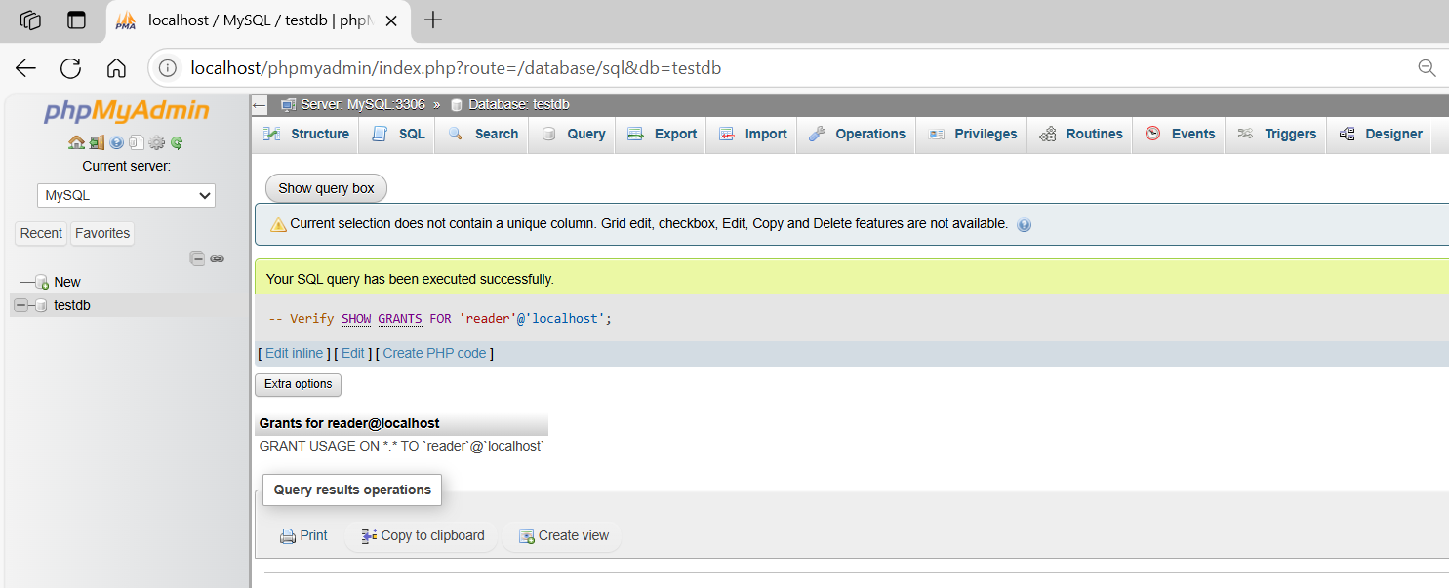

Example 2

prepared commands
# Source: ScreenShot Source: Provided by: [Persons Table -> ID Column: 1, Name_En Column: Motasem Essam] -> Tool: [Automation Table -> ID Column: 16, Name_En Column: Screen Capture] -> From [Operating System: Wampserver64 -> phpmyadmin] on [6/11/2026]

-- Create user
CREATE USER 'reader'@'localhost' IDENTIFIED BY 'initialpass';


basic command
# Source: ScreenShot Source: Provided by: [Persons Table -> ID Column: 1, Name_En Column: Motasem Essam] -> Tool: [Automation Table -> ID Column: 16, Name_En Column: Screen Capture] -> From [Operating System: Wampserver64 -> phpmyadmin] on [6/11/2026]
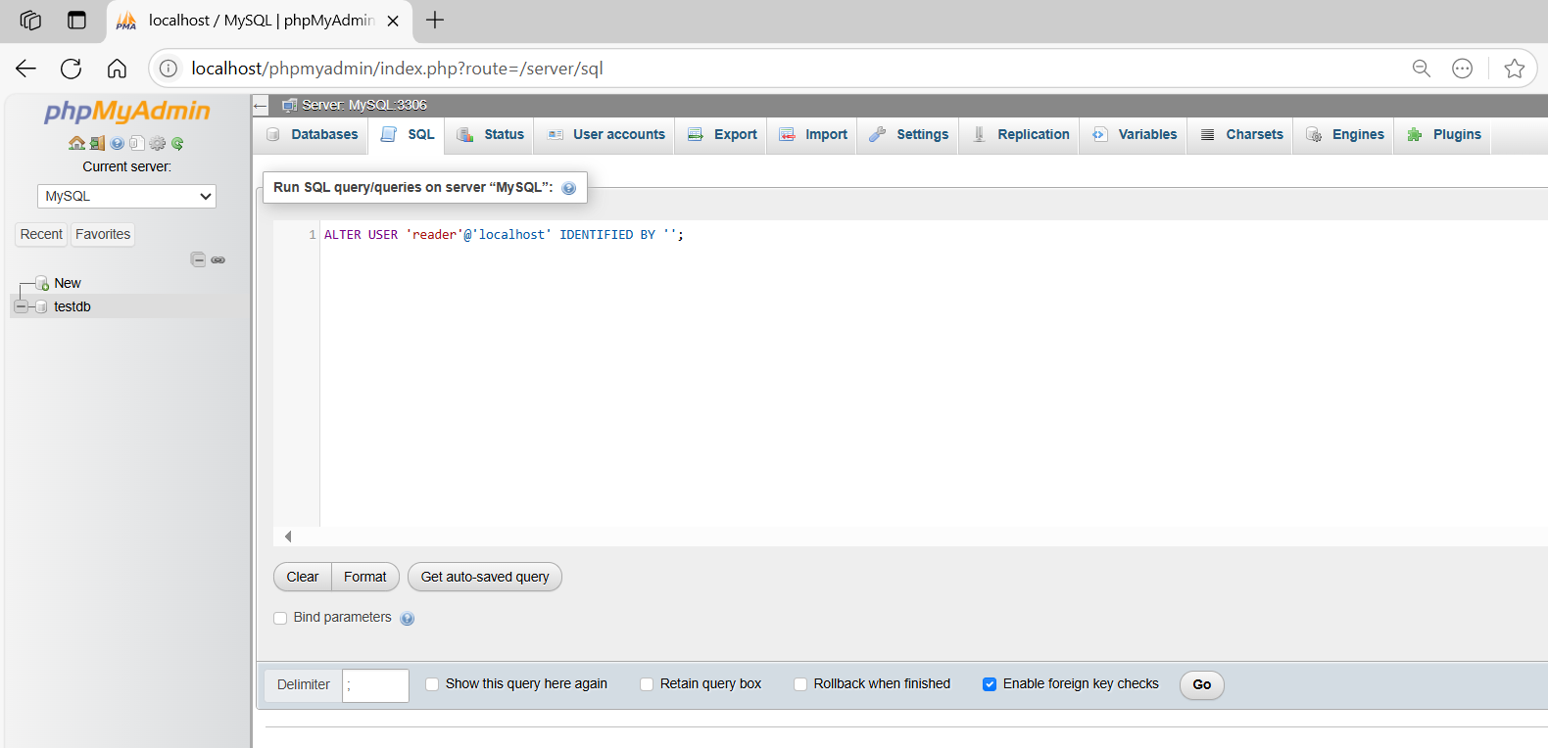
ALTER USER 'reader'@'localhost' IDENTIFIED BY '';
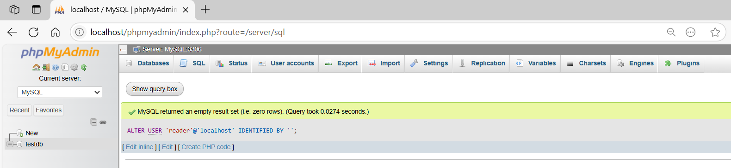

Example 3

basic command
# Source: ScreenShot Source: Provided by: [Persons Table -> ID Column: 1, Name_En Column: Motasem Essam] -> Tool: [Automation Table -> ID Column: 16, Name_En Column: Screen Capture] -> From [Operating System: Wampserver64 -> phpmyadmin] on [6/11/2026]

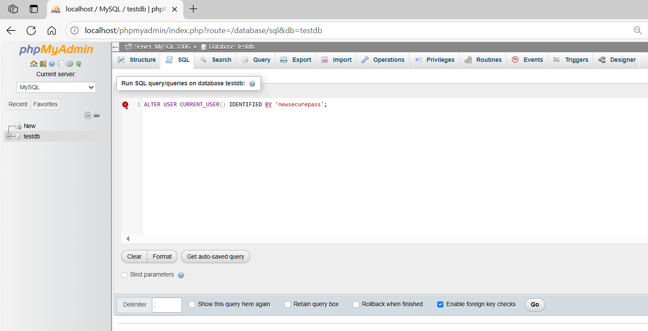
ALTER USER CURRENT_USER() IDENTIFIED BY 'newsecurepass';
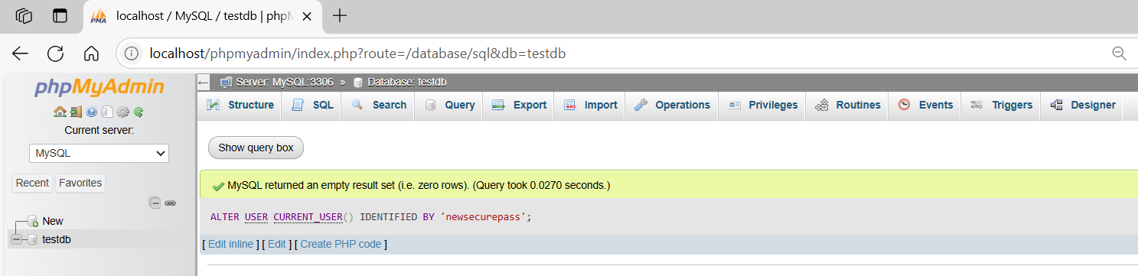
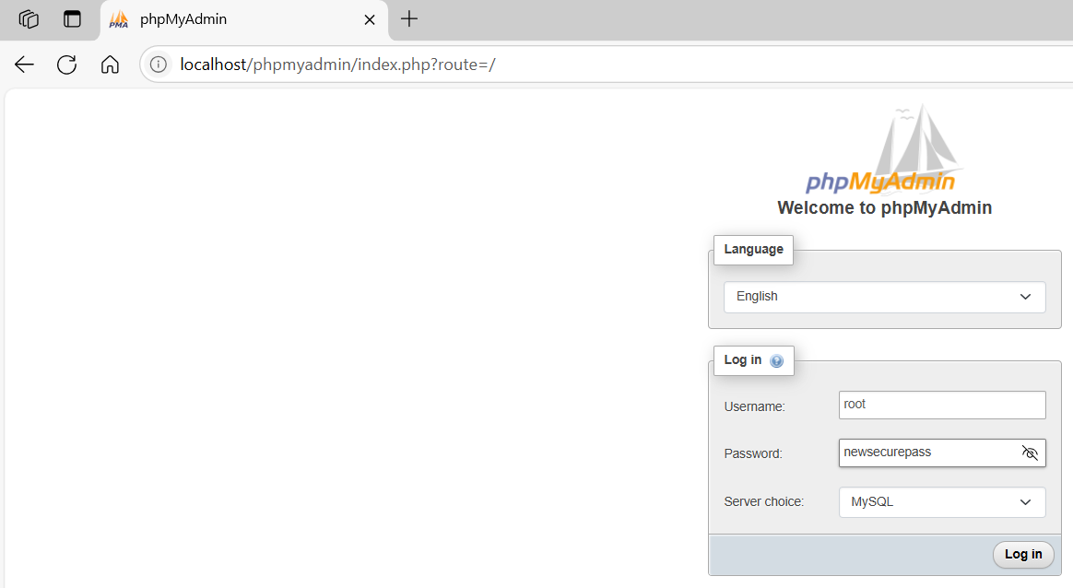
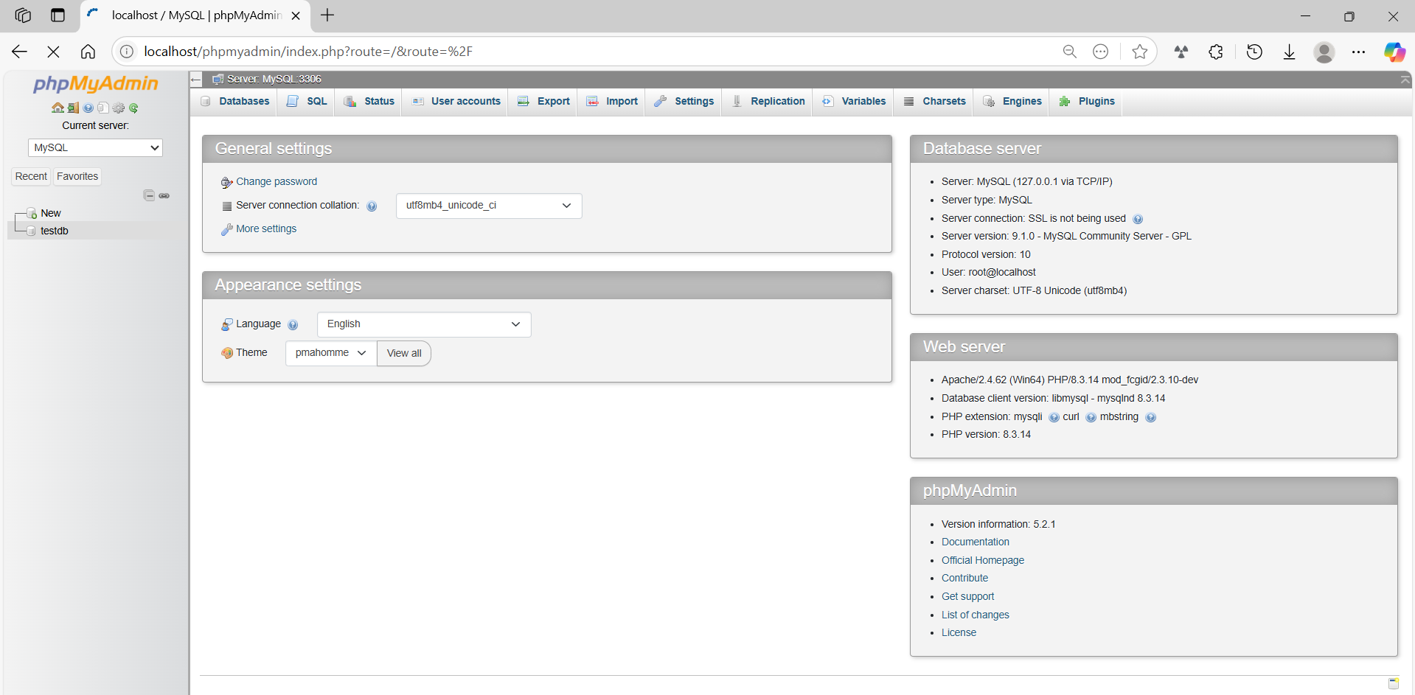
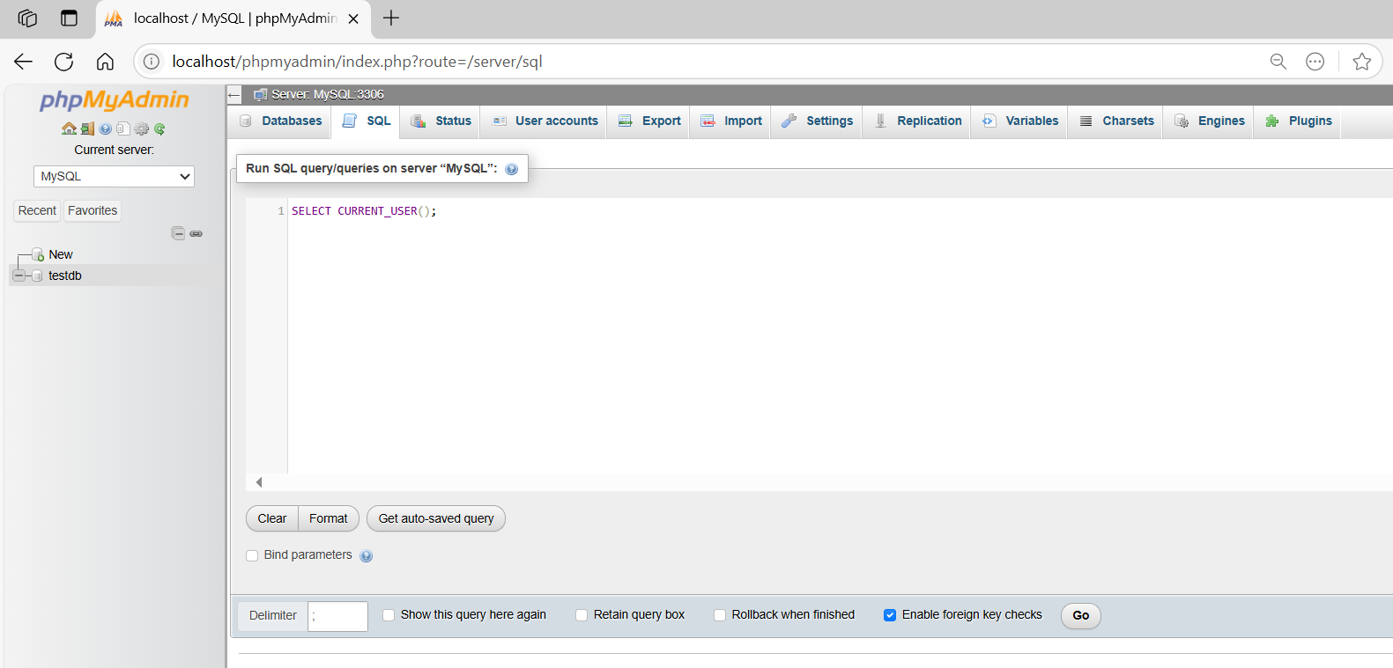
SELECT CURRENT_USER();

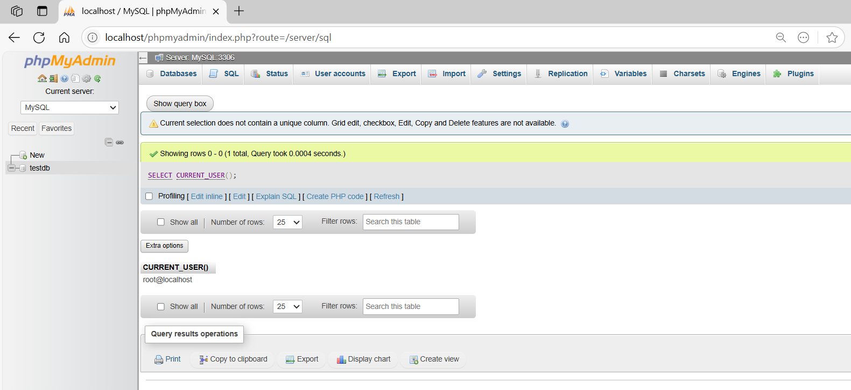

Example 4

basic command
# Source: ScreenShot Source: Provided by: [Persons Table -> ID Column: 1, Name_En Column: Motasem Essam] -> Tool: [Automation Table -> ID Column: 16, Name_En Column: Screen Capture] -> From [Operating System: Wampserver64 -> phpmyadmin] on [6/11/2026]
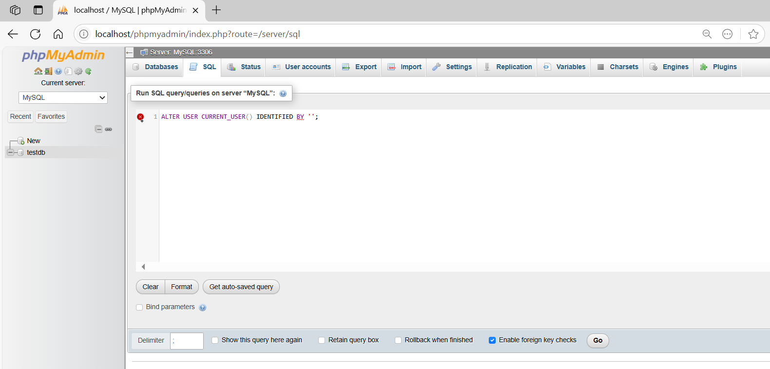
ALTER USER CURRENT_USER() IDENTIFIED BY '';
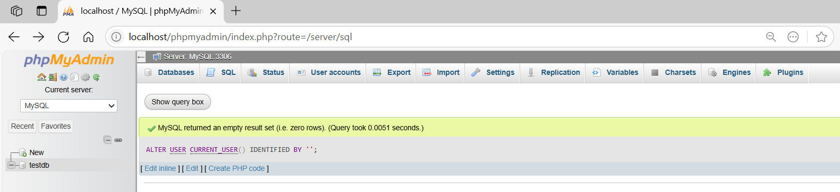
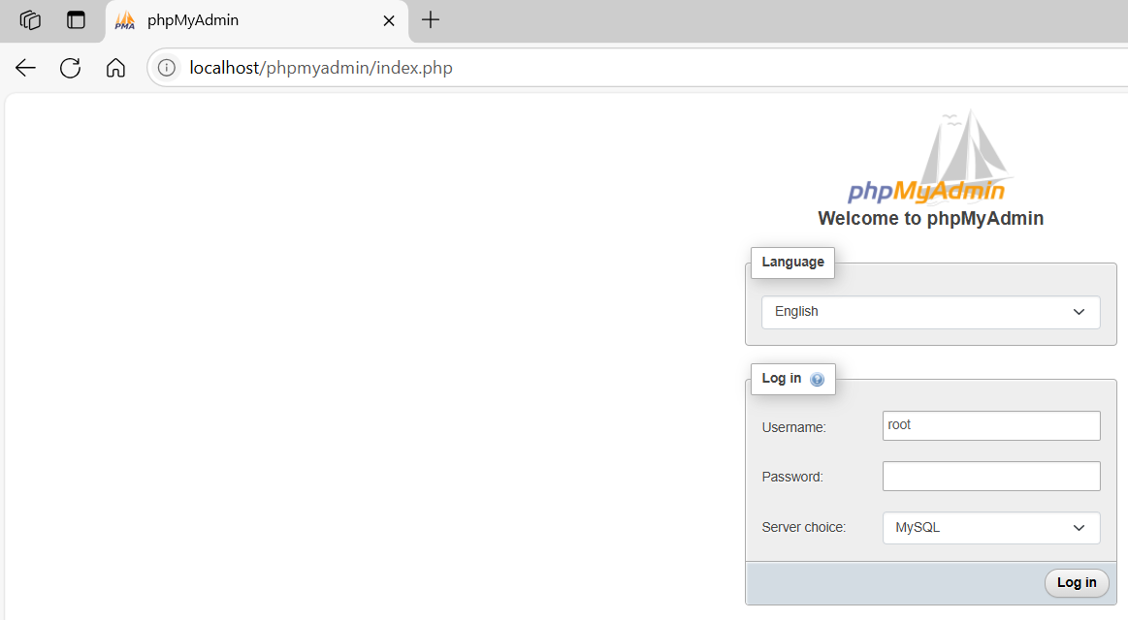
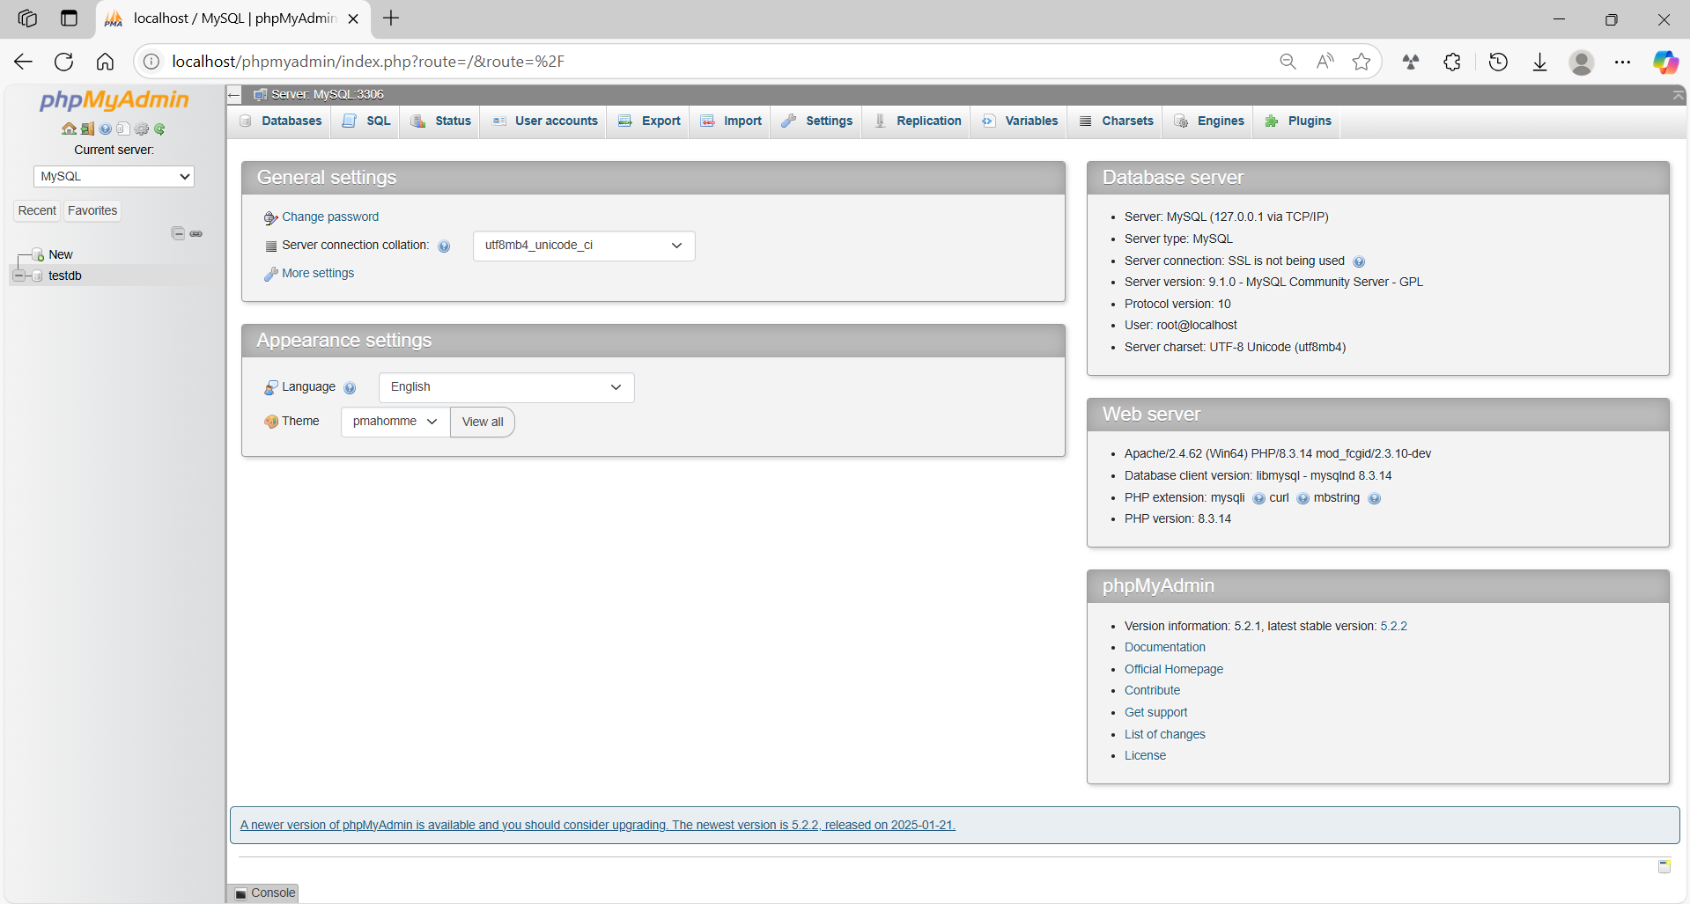
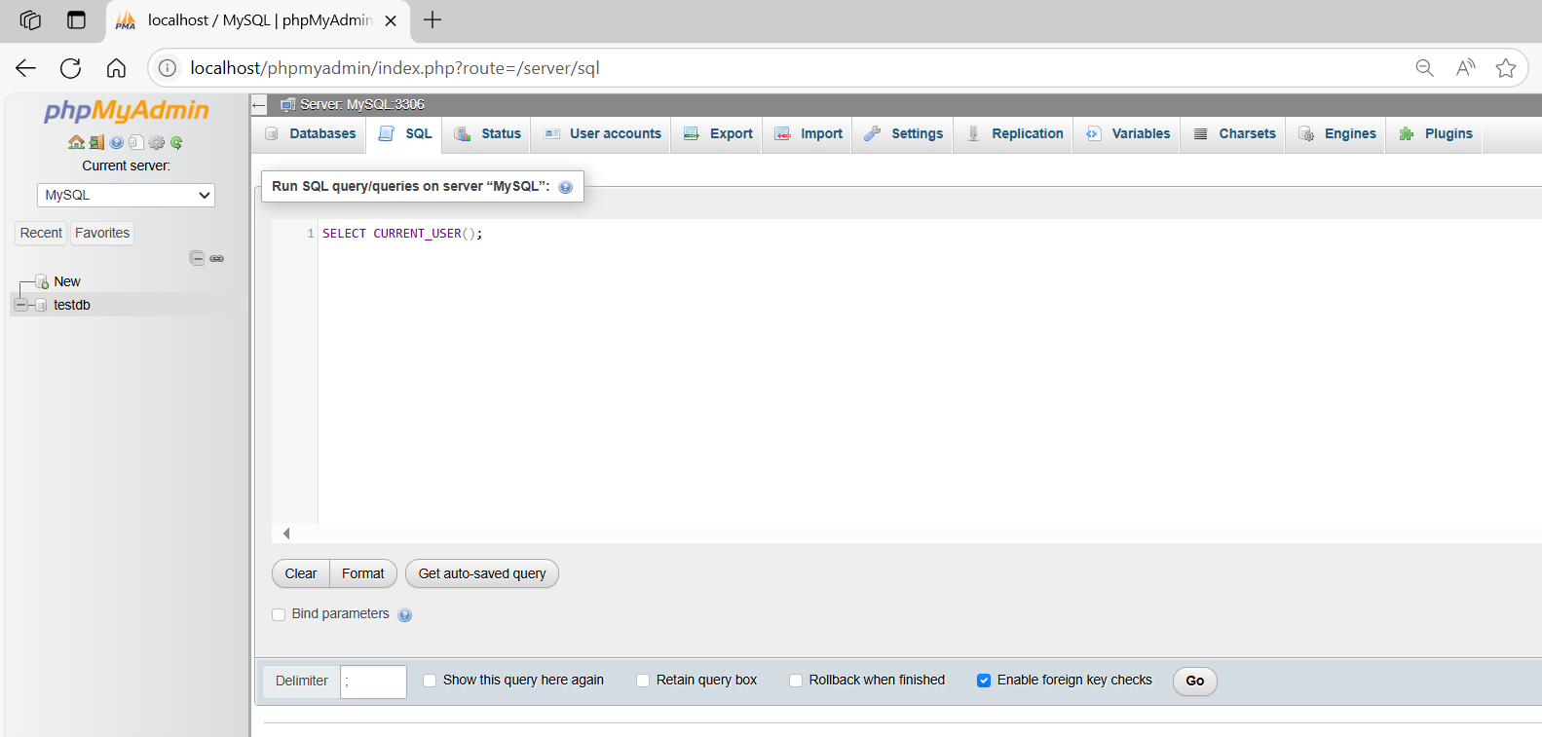
SELECT CURRENT_USER();
